Revamping a 1TB Hard Drive into a Raspberry Pi NAS with OpenMediaVault
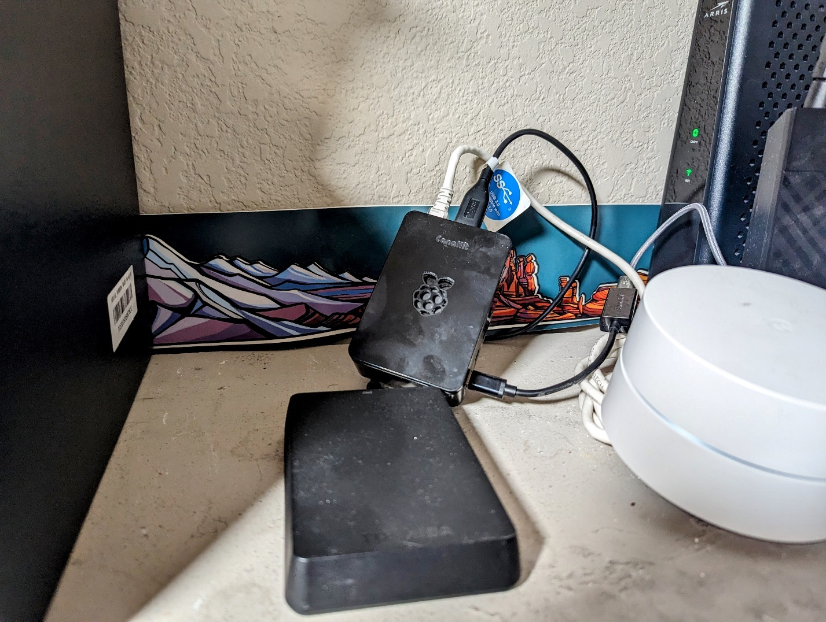

In a world dominated by digital data, storage solutions become paramount. When faced with the limitations of a 1TB external hard drive, I decided to repurpose it into a Network Attached Storage (NAS) system using a Raspberry Pi 4 and OpenMediaVault.

Following a guide from Pimylifeup.com, I embarked on the installation process. However, a critical note was missed: rebooting the Pi as instructed disabled the eth0 interface, leaving me stranded. After resolving this setback by re-flashing the Pi OS with a 64-bit headless install, I could finally access the OpenMediaVault web portal to continue configuration.
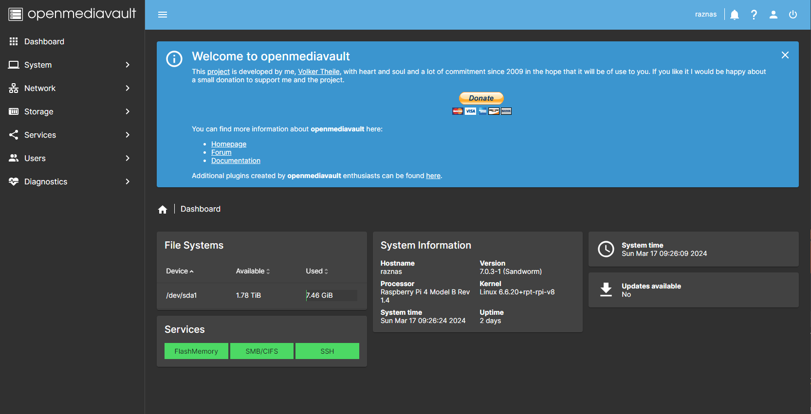

Despite initial challenges, the user-friendly interface of OpenMediaVault allowed for smooth setup and customization of the NAS. With perseverance and a touch of troubleshooting, the project was successfully completed. To test things out, I decided to backup my local downloads folder. I was pretty satisfied with the transfer speeds (ethernet connection). One other issue I came across was mapping this drive to other machines required me to create more users (only one user per machine map).
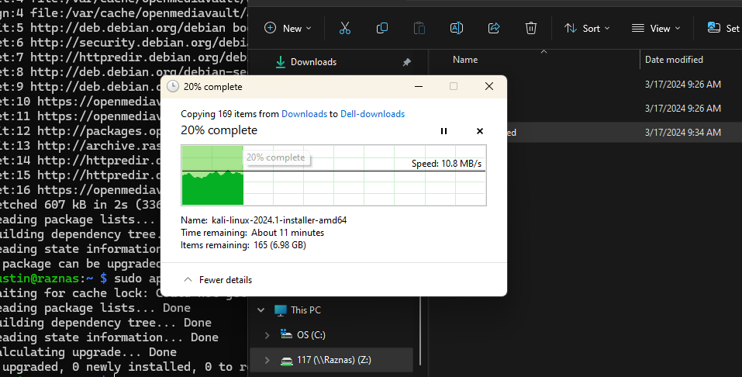
In conclusion, repurposing an external hard drive into a Raspberry Pi NAS is a feasible DIY project with the right tools and guidance. While there may be hurdles along the way, the end result offers expanded storage and data management capabilities.

